**Lab Exercise 12**

**Creating a Conditional Workflow**

**Objective:** To create a conditional workflow to specify when a particular job or step should run

**Tools required:** GitHub Actions

**Prerequisites:** None

Steps to be followed:

1. Create a new GitHub repository
2. Create and execute a new conditional workflow file

**Step 1: Create a new GitHub repository**

1. Open the browser in your lab, go to **github.com**, and log in to your account

**Note**: If you do not have a GitHub account, visit the official website at <https://github.com/signup> and create a new account

1. Click on the **+** icon from the upper-right corner of the page and select **New repository** from the drop-down menu

1. Enter the name and description for the GitHub repository

1. Choose **Public** for the repository type

1. Select **Initialize this repository with a README** to include a README file for the repository

1. Click on the **Create repository** button

The repository is created.

**Step 2: Create and execute a new conditional workflow file**

* 1. Navigate to the **Actions** tab and click on **set up a workflow yourself** to create a **.github/workflows** directory

* 1. Create a new workflow file **conditional3.yml** with the below code, and then click on **Commit changes**:

**name: Conditional Workflow Execution**

**on:**

**push:**

**branches:**

**- main**

**- feature/\***

**jobs:**

**production-deploy:**

**if: startsWith(github.ref, 'refs/heads/feature/') || github.ref == 'refs/heads/main'**

**runs-on: ubuntu-latest**

**steps:**

**- uses: actions/checkout@v3**

**- uses: actions/setup-node@v3**

**with:**

**node-version: '14'**

* 1. Add the **Commit message** as **Create conditional3.yml** and click on **Commit changes** to save the workflow file in the code repository

* 1. Navigate to the **Actions** tab in the repository to access the workflow execution and click on the **Create conditional3.yml** workflow

* 1. Click on **production-deploy** to see the output



The following **production-deploy** screen will appear:

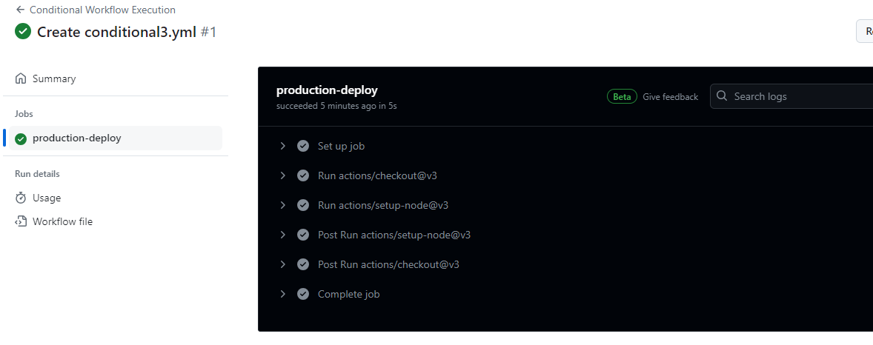

* 1. Expand the output under the **production-deploy**

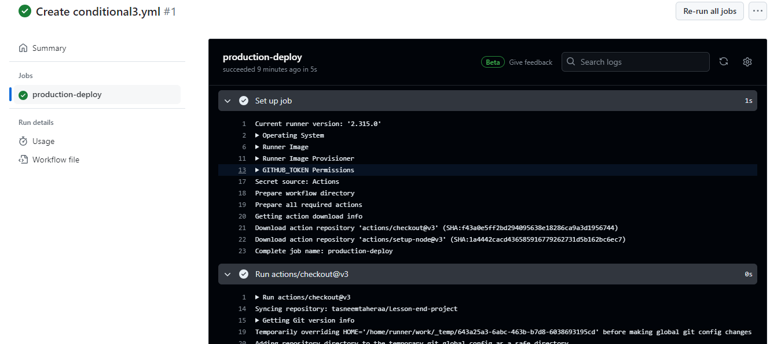

By following these steps, you have successfully created the conditional workflow to specify when a particular job or step should run.